**EXPERIMENT 10**

**Basics of ROS**

**Aim:**

To install the ROS Noetic version and learn to create a workspace in ROS and to run simple program.

**Software/ Package Used:**

* Ubuntu 18.04
* ROS - Noetic

**Programs:**

**1. Write a ROS program to configure a node and send a message and configure two different users to receive the same message.**

**PUBLISHER CODE:**

#!/usr/bin/env python3

import rospy

from std_msgs.msg import String

def talker():

pub = rospy.Publisher('chatter', String, queue_size=10)

rospy.init_node('talker', anonymous=True)

rate = rospy.Rate(10) # 10hz

while not rospy.is_shutdown():

hello_str = "hello world %s" % rospy.get_time()

rospy.loginfo(hello_str)

pub.publish(hello_str)

rate.sleep()

if __name__ == '__main__':

try:

talker()

except rospy.ROSInterruptException:

pass

**SUBSCRIBER 1 CODE:**

#!/usr/bin/env python3

import rospy

from std_msgs.msg import String

def callback(data):

rospy.loginfo(rospy.get_caller_id() + 'I heard %s', data.data)

def listener():

rospy.init_node('listener', anonymous=True)

rospy.Subscriber('chatter', String, callback)

# spin() simply keeps python from exiting until this node is stopped

rospy.spin()

if __name__ == '__main__':

listener()

**SUBSCRIBER 2 CODE:**

#!/usr/bin/env python3

import rospy

from std_msgs.msg import String

def callback(data):

rospy.loginfo(rospy.get_caller_id() + 'I heard as well %s', data.data)

def listener():

rospy.init_node('listener', anonymous=True)

rospy.Subscriber('chatter', String, callback)

rospy.spin()

if __name__ == '__main__':

listener()

**OUTPUT:**

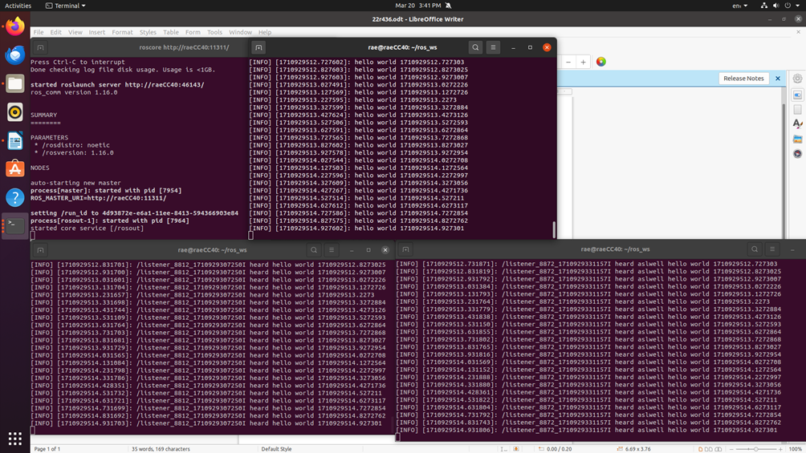

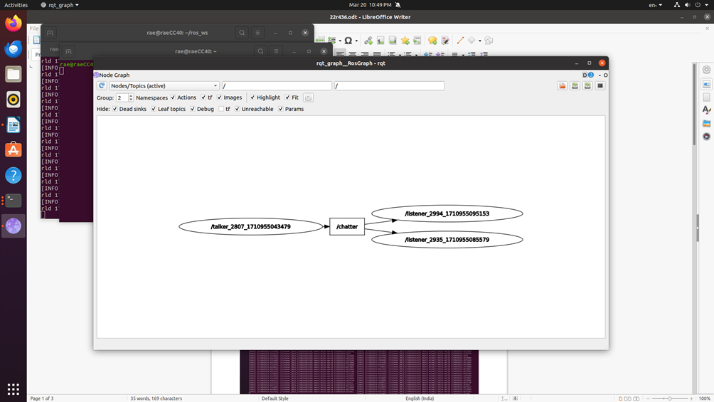

**2. Run turtlesim**

**COMMANDS:**

* rosrun turtlesim turtlesim_node
* rosrun turtlesim turtle_teleop_key
* rqt_graph

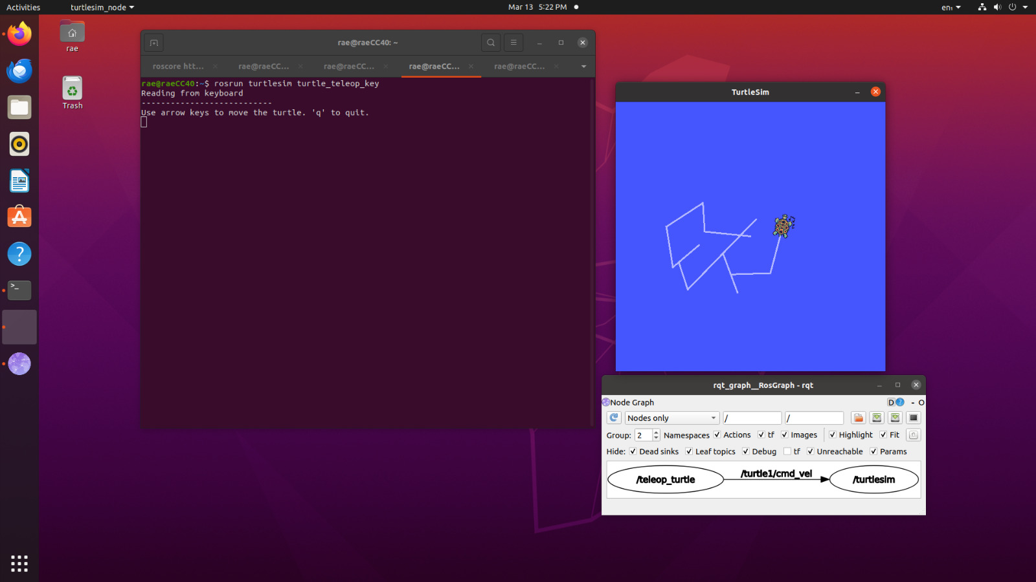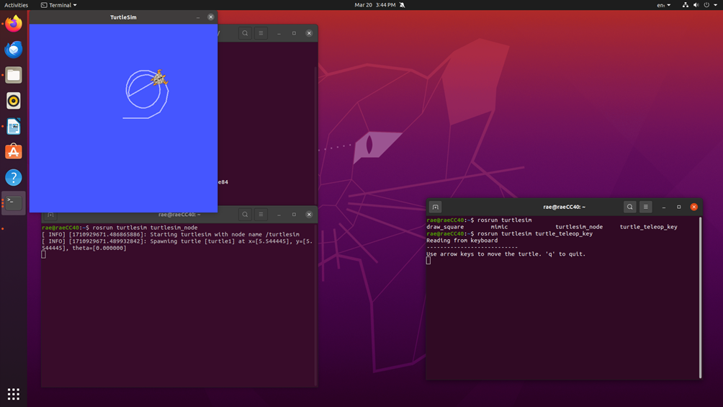**OUTPUT:**

**3. RQT Graph.**

**COMMANDS:**

* rqt_graph

**OUTPUT:**

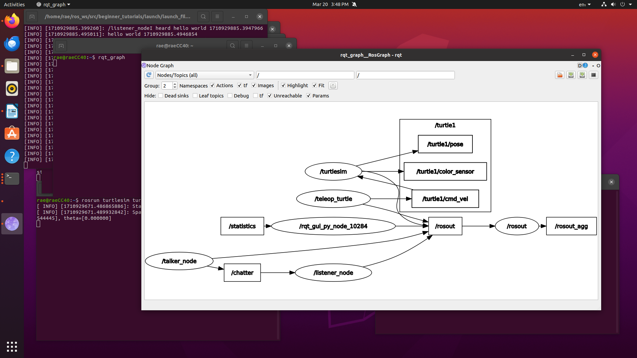

**4. Bridge ROS with openCV. Read an image into ROS and rotate the image.**

**CODE:**

#!/usr/bin/env python3

import rospy # Python library for ROS

from sensor_msgs.msg import Image # Image is the message type

from cv_bridge import CvBridge # Package to convert between ROS and OpenCV Images

import cv2 # OpenCV library

def callback(data):

br = CvBridge()

rospy.loginfo("receiving video frame")

current_frame = br.imgmsg_to_cv2(data)

current_frame=cv2.circle(current_frame,(60,60),10,(0,255,255),-1)

current_frame=cv2.rotate(current_frame,cv2.ROTATE_90_CLOCKWISE)

cv2.imshow("camera", current_frame)

cv2.waitKey(0)

def receive_message():

rospy.init_node('video_sub_py', anonymous=True)

rospy.Subscriber('video_frames', Image, callback)

rospy.spin()

cv2.destroyAllWindows()

if _name_ == '_main_':

receive_message()

**OUTPUT:**

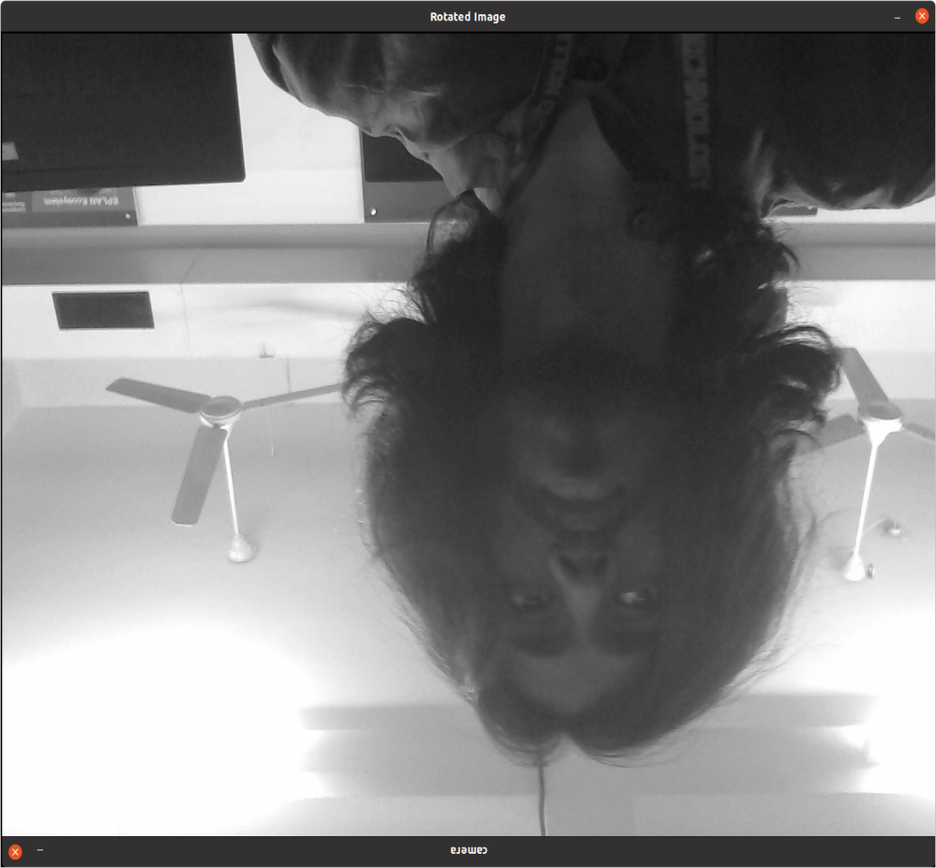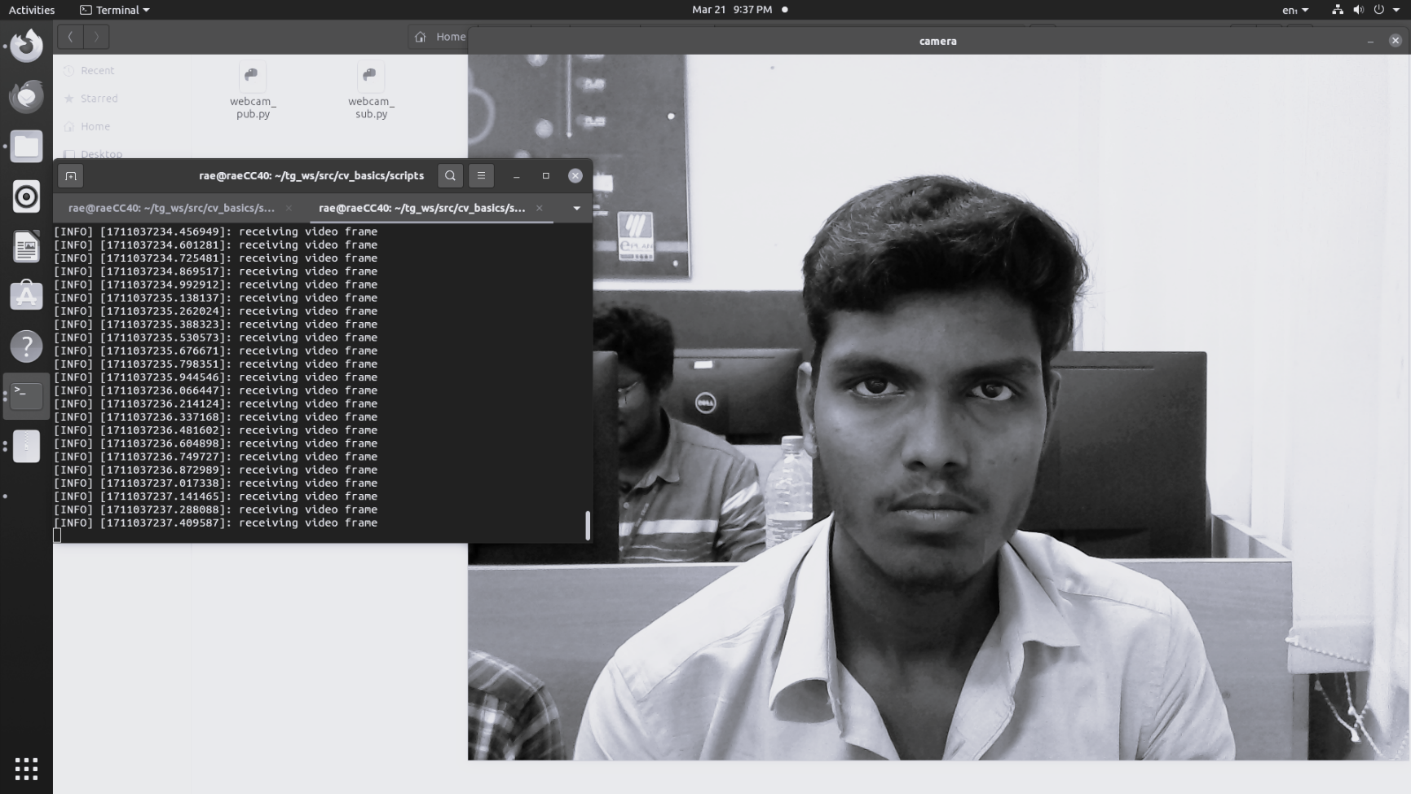

**5. Read an image into ROS and perform color conversions on an image.**

**CODE:**

#!/usr/bin/env python3

import rospy # Python library for ROS

from sensor_msgs.msg import Image # Image is the message type

from cv_bridge import CvBridge # Package to convert between ROS and OpenCV Images

import cv2 # OpenCV library

def publish_message():

pub = rospy.Publisher('video_frames', Image, queue_size=10)

rospy.init_node('video_pub_py', anonymous=True)

rate = rospy.Rate(10) # 10hz

cap = cv2.imread('/home/rae/Downloads/test.png',0)

br = CvBridge()

while not rospy.is_shutdown():

if True:

rospy.loginfo('publishing video frame')

pub.publish(br.cv2_to_imgmsg(cap))

rate.sleep()

if _name_ == '_main_':

try:

publish_message()

except rospy.ROSInterruptException:

pass

**OUTPUT:**

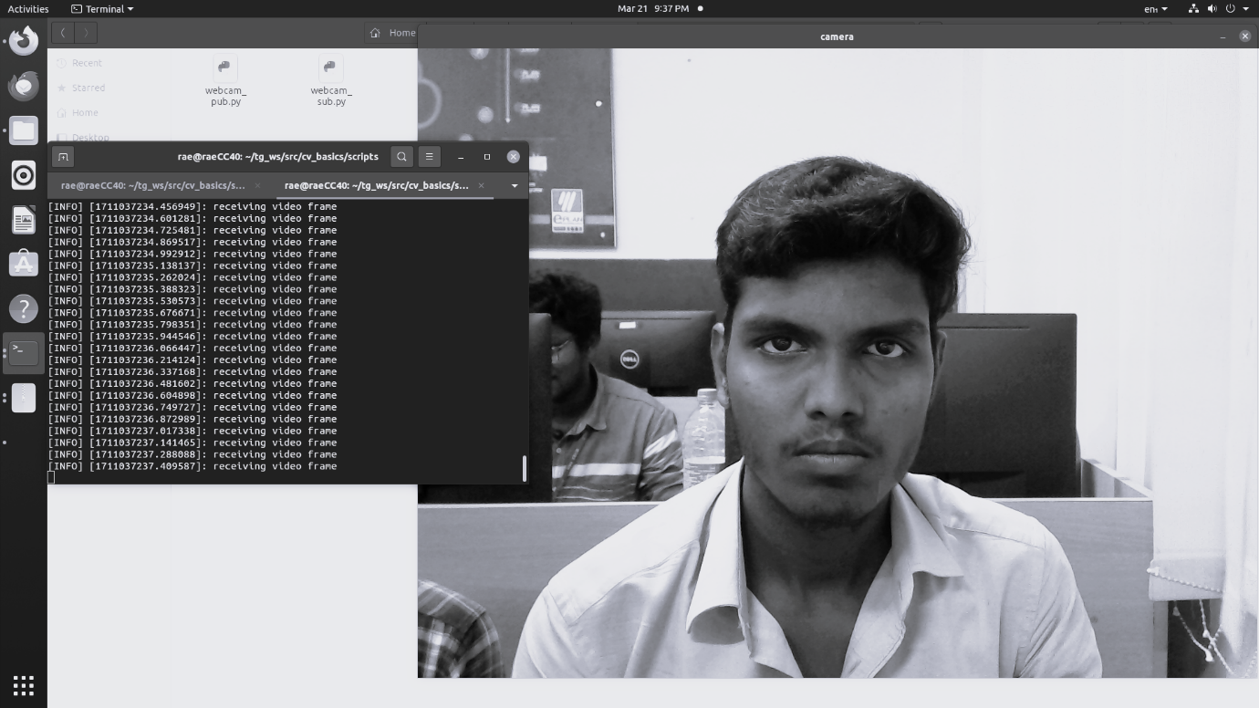

**6. Write AI and vison on an image.**

**CODE:**

#!/usr/bin/env python3

import rospy # Python library for ROS

from sensor_msgs.msg import Image # Image is the message type

from cv_bridge import CvBridge # Package to convert between ROS and OpenCV Images

import cv2 # OpenCV library

def publish_message():

pub = rospy.Publisher('video_frames', Image, queue_size=10)

rospy.init_node('video_pub_py', anonymous=True)

rate = rospy.Rate(10) # 10hz

cap = cv2.imread('/home/rae/Downloads/black screen.png')

current_frame=cv2.putText(current_frame,"AI & VISION",(50,50),cv2.FONT_HERSHEY_SIMPLEX,1,(255,0,255),2,cv2.LINE_AA)

br = CvBridge()

while not rospy.is_shutdown():

if True:

rospy.loginfo('publishing video frame')

pub.publish(br.cv2_to_imgmsg(cap))

rate.sleep()

if _name_ == '_main_':

try:

publish_message()

except rospy.ROSInterruptException:

pass

**OUTPUT:**

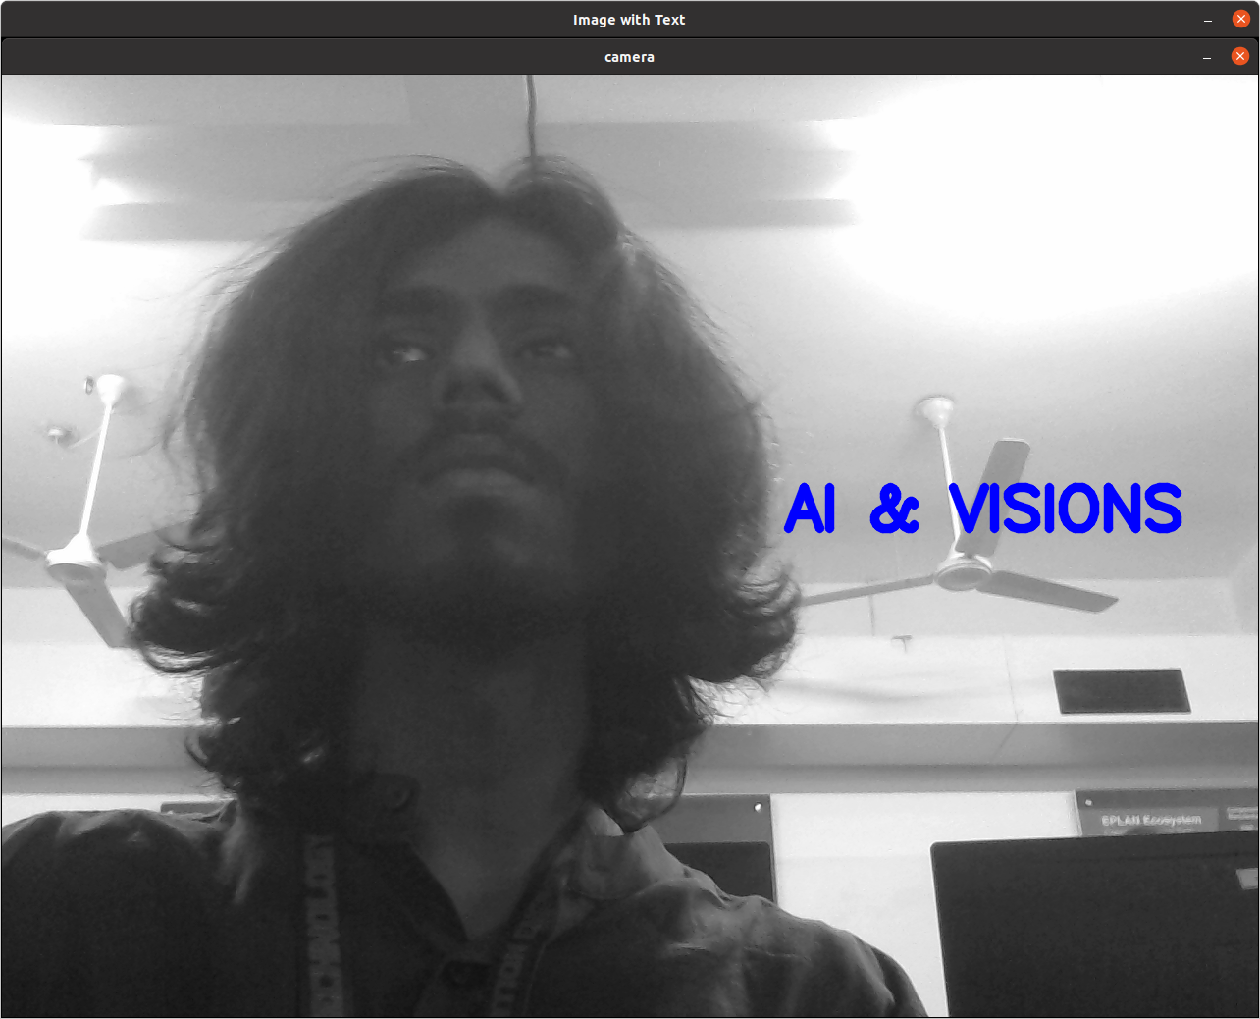

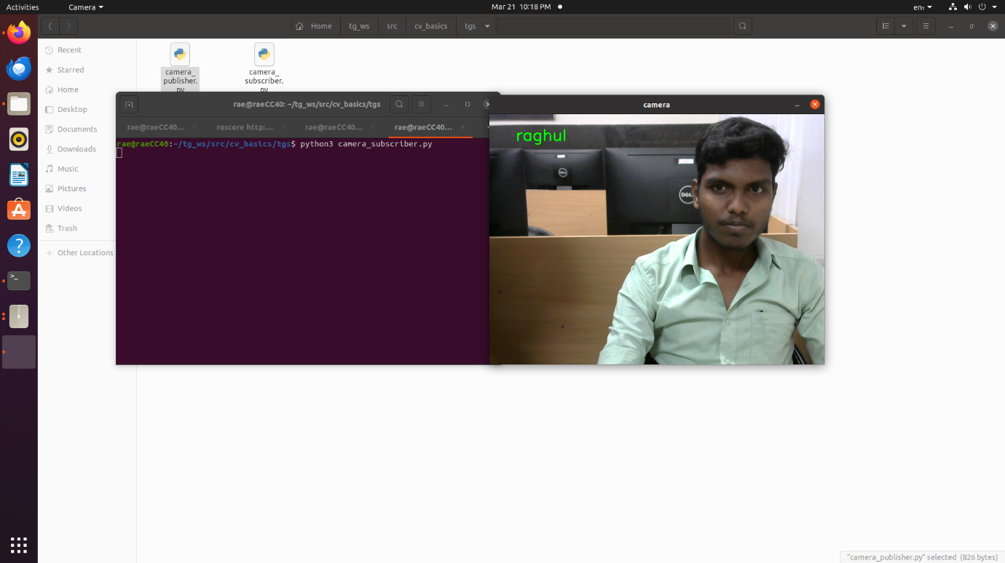

**AI & VISIONS**

**7. Find the difference between the two images.**

**CODE:**

import rospy # Python library for ROS

from sensor_msgs.msg import Image # Image is the message type

from cv_bridge import CvBridge # Package to convert between ROS and OpenCV Images

import cv2 # OpenCV library

def publish_message():

pub = rospy.Publisher('video_frames', Image, queue_size=10)

rospy.init_node('video_pub_py', anonymous=True)

rate = rospy.Rate(10) # 10hz

cap = cv2.imread('/home/rae/Downloads/test.png',0)

br = CvBridge()

while not rospy.is_shutdown():

rospy.loginfo('publishing video frame')

pub.publish(br.cv2_to_imgmsg(cap))

rate.sleep()

if _name_ == '_main_':

try:

publish_message()

except rospy.ROSInterruptException:

pass

**OUTPUT:**

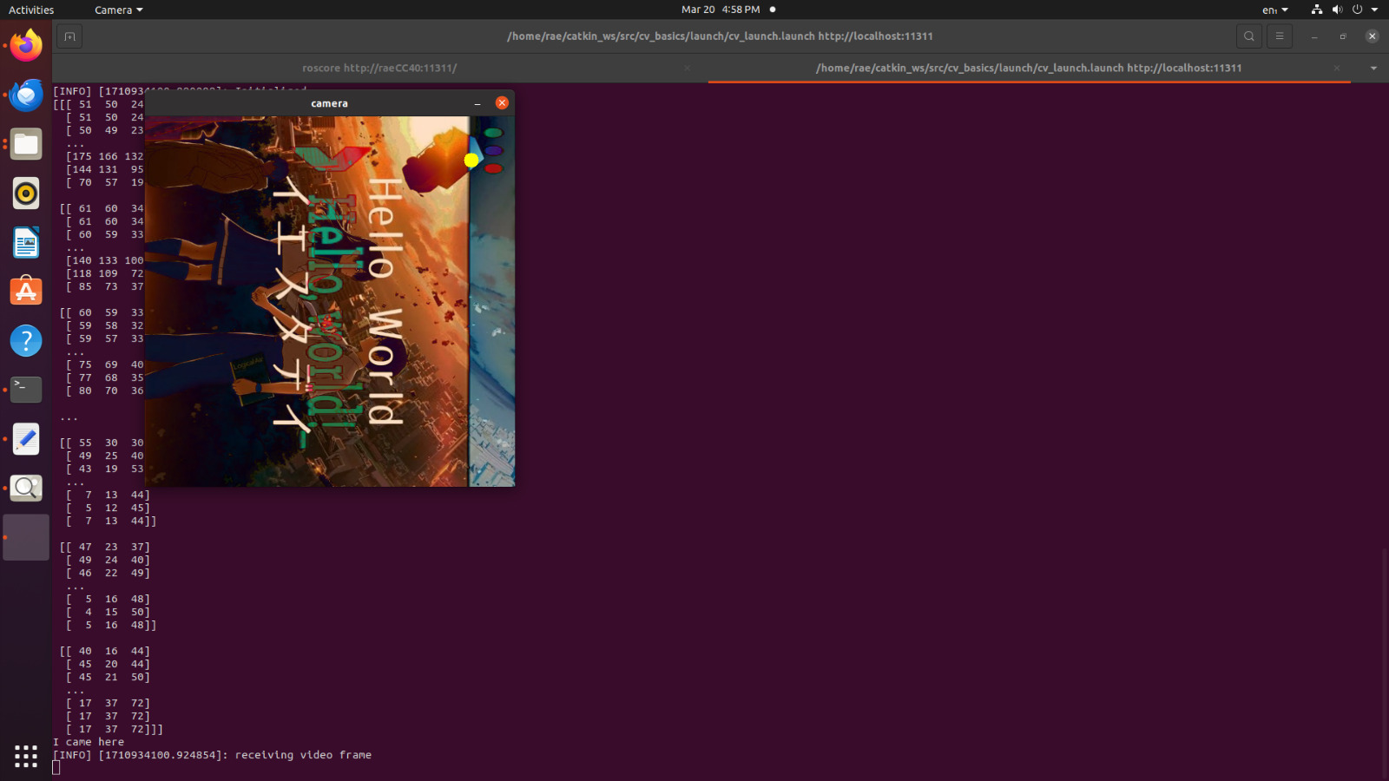

**8. Write a python program in ROS to sort a given set of numbers.**

**CODE:**

import rospy

from std_msgs.msg import Int32MultiArray

def sort_numbers(numbers):

sorted_numbers = sorted(numbers.data) rospy.loginfo("Sorted Numbers: {}".format(sorted_numbers)) return sorted_numbers

def numbers_callback(data):

rospy.loginfo("Received Numbers: {}".format(data.data)) sorted_numbers = sort_numbers(data)

rospy.signal_shutdown("Numbers sorted successfully. Shutting down...") # Shutdown after sorting

def numbers_sorter(): rospy.init_node('numbers_sorter', anonymous=True)

numbers = Int32MultiArray(data=[5, 2, 8, 1, 9]) # Predefined numbers to sort sorted_numbers = sort_numbers(numbers)

rospy.loginfo("Sorted Numbers: {}".format(sorted_numbers)) rospy.spin()

if name == ' main ':

try:

numbers_sorter()

except rospy.ROSInterruptException:

pass

**OUTPUT:**

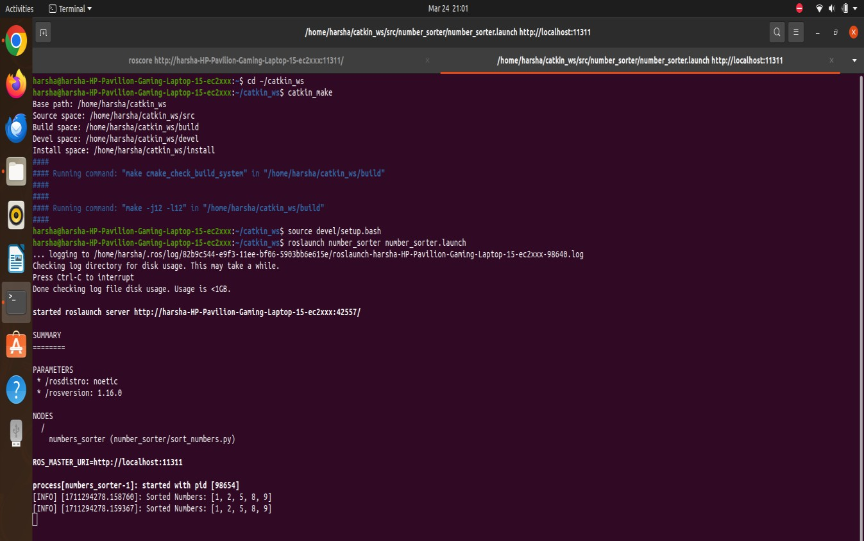

**9. Stream the video from USB camera in RoS and write your name on the Stream.**

**CODE**:

#!/usr/bin/env python3

import rospy # Python library for ROS

from sensor_msgs.msg import Image # Image is the message type

from cv_bridge import CvBridge # Package to convert between ROS and OpenCV Images

import cv2 # OpenCV library

def callback(data):

br = CvBridge()

rospy.loginfo("receiving video frame")

current_frame = br.imgmsg_to_cv2(data)

current_frame=cv2.putText(current_frame,"hiiiii",(50,50),cv2.FONT_HERSHEY_SIMPLEX,1,(255,0,255),2,cv2.LINE_AA)

current_frame=cv2.circle(current_frame,(60,60),10,(0,255,255),-1)

cv2.imshow("camera", current_frame)

cv2.waitKey(1)

def receive_message():

rospy.init_node('video_sub_py', anonymous=True)

rospy.Subscriber('video_frames', Image, callback)

rospy.spin()

cv2.destroyAllWindows()

if _name_ == '_main_':

receive_message()

**OUTPUT:**

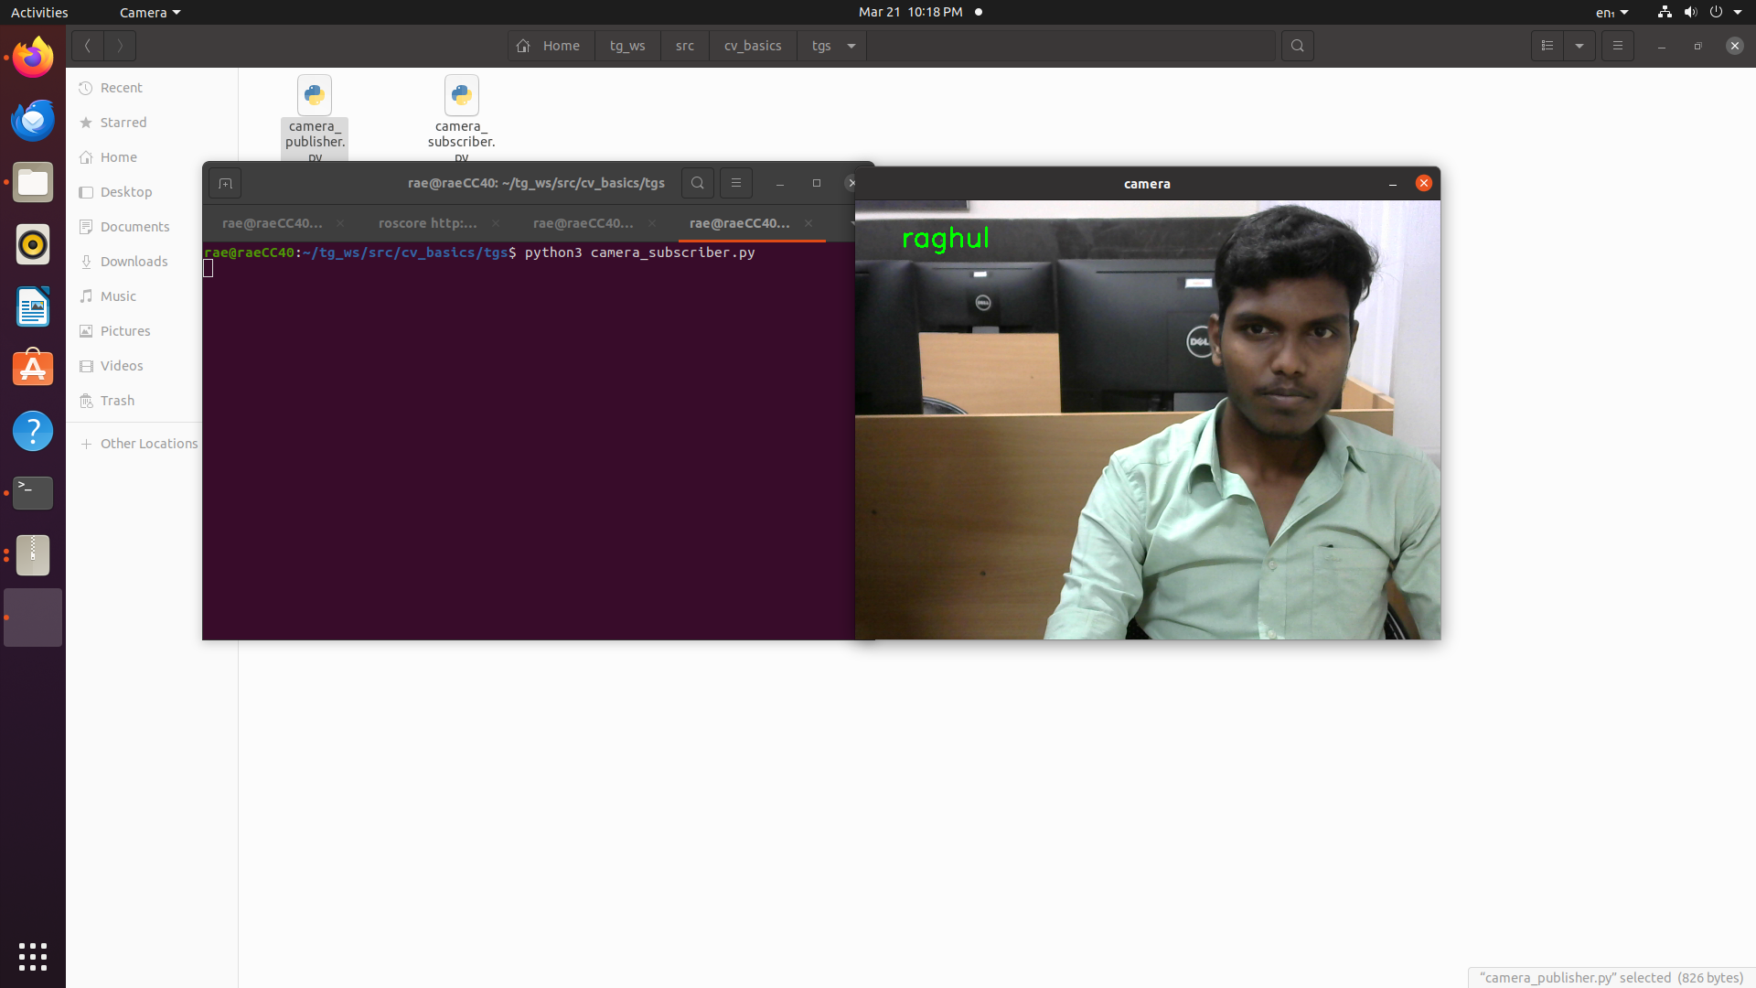

**10. Simulate a world of your own in Gazebo and Rviz and spawn a turtlebot on it.**

**Environment with turtlebot 3 has been setup:**

**SETUP:**

Download link:

https://github.com/SakshayMahna/Robotics-Playground/tree/main/turtlebot3_ws

Unzip into home dir.

Open terminal

roscore

Open another terminal

sudo apt-get install ros-noetic-navigation

Open another terminal

cd turtlebot3_ws/

catkin_make

source devel/setup.bash

**TO RUN TURTLEBOT3:**

Terminal 1

roscore

Terminal 2

cd turtlebot3_ws/

catkin_make

source devel/setup.bash

roslaunch ros_world turtlebot3_world.launch

Terminal 3

cd turtlebot3_ws/

catkin_make

source devel/setup.bash

roslaunch global_path_planning turtlebot3_ros_world.launch

Terminal 4

cd turtlebot3_ws/

catkin_make

source devel/setup.bash

rosrun global_path_planning path_planning_server.py

**OUTPUT**:

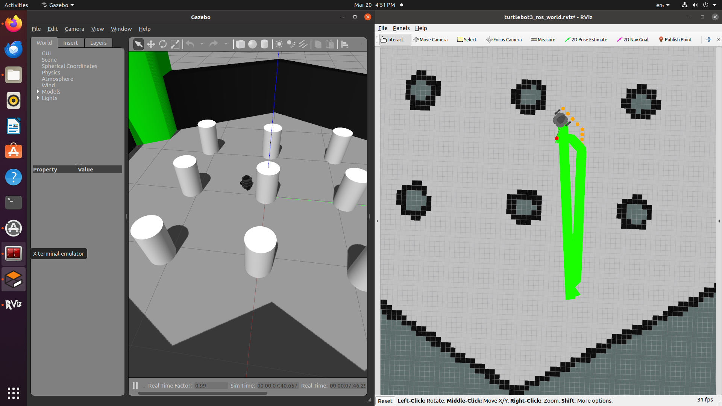

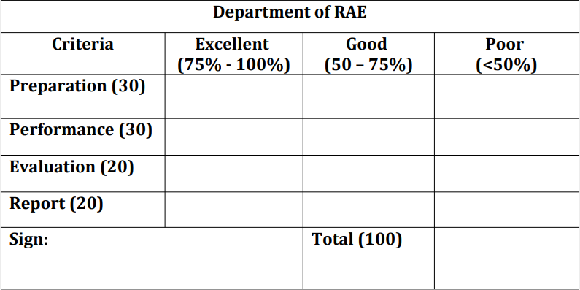

**Result:**

Thus, the ROS basics has been successfully implemented.